1. spring-boot-starter-web  
   
   1. It includes a group of related dependencies.
   2. It also manage the versions among those dependencies.
2. spring-boot-starter-parent  
   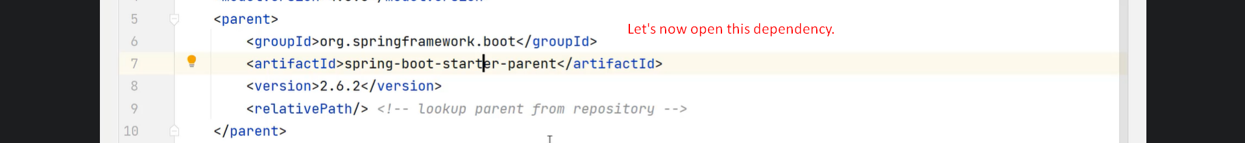
   1. Graphical user interface, text

      Description automatically generated
3. 
4. Graphical user interface, text, application

   Description automatically generated
5. The request will go to DisptacherServlet which was configured automatically by Spring Boot.
6. Graphical user interface, text, application, email

   Description automatically generated
7. Text

   Description automatically generated with low confidence
8. A picture containing text

   Description automatically generated